Information System



**Module Code & Module Title**

**Final Year Project**

**CS6P05**

**Coursework**

**Module Code & Module Title**

**CS6P05 Final Year Project**

**Assessment Weightage & Type**

**Individual Coursework**

**Year and Semester**

**2018-20**

**Student Name: Prijesh Sharma**

**London Met ID: 17030981**

**College ID: NP01CP4A170202**

**External Supervisor: Shekhar Timisina**

**Internal Supervisor: Rohit Pandey**

I confirm that I understand my coursework needs to be submitted online via Google Classroom under the relevant module page before the deadline in order for my assignment to be accepted and marked. I am fully aware that late submissions will be treated as non-submission and a marks of zero will be awarded.

**Proposal Structure for FYP-2019/20**

Contents

1. Introduction: 3

a. Problem scenario 3

b. Project as a solution 3

2. Aim: 3

3. Objectives: 3

4. Expected Outcomes and Deliverables: 4

5. Project risks, threats and contingency plans: 4

6. Methodology: 4

7. Features 5

8. Design or a Basic Layout of website 6

9. Resource Requirements: 6

10. Work breakdown structure: 6

11. Milestones: 7

12. Project Gantt chart with correct activity sequencing, duration and milestones 7

13. Conclusion of the given proposal. 8

14. Clients 8

15. References 8

# 1. Introduction:

In this world of Globalization and Computerization the ever evolving and changing requirements with fast speed necessitates the latest and comprehensive applications in various sectors. This project looks forward to bridge the gap between the demand and supply of various professionals. It aids to fulfilling the concept of this world as a Global village.

This Application “GloPro” (Global Professionals) looks forward for developing a comprehensive list of professionals segregating it by drop down menu for different professions in different countries. It targets for freelancing services for long term, short term or piecemeal basis. Also the services may be offered and/or provided at an individual level or organizational level. This application starts with catering to the requirement of few selected professions and aims at expanding to exhaustive list of various individual skills as it grows so that it caters to the requirements of common people down the line as well. The site will also cater to the promotional requirements of the companies as they wish.

# Problem scenario

The fast changing technology calls for new and specific specializations leading to requirements of professionals with specific and in-depth caliber in certain fields. Also, many a time’s requirements are found for a certain job and/or certain period of time only.

# Project as a solution

This project fosters for a one stop solution for all the job seekers and job providers. It will start to cater the needs of few professions like Information Technology, Chartered Accountancy, Actuarial Science, Law and targets to cover the various exhaustive list of professions as we grow. It would cater to long term, short term or piecemeal requirements of the job.

# 2. Aim:

The project aims at developing a web development for various professionals and providing a one stop, user friendly application.

# 3. Objectives:

* This Application aims at catering to exhaustive categories of users starting with specialized profession and extending to individual skills as it grows so that it reaches the masses.
* It looks forward to interact in most user friendly way.
* It foresees for optimizing the overrated cost for the end users by providing competitive choice.
* It facilitates outsourcing expertise at competitive cost and also caters to avoid the union problems of third world countries.
* It also provides a platform for promotion of companies.

# 4. Expected Outcomes and Deliverables:

* A user friendly Application of seeking and providing professionals.
* A user documentation

5. Project risks, threats and contingency plans:

Even the most carefully planned project can run into trouble. No matter how well I plan, the project can always encounter unexpected problems. Resources that the project will be depending on can turn out to be unavailable. One might get sick or try to quit. So that calls for risk planning to identify potential problems that could cause trouble for my project, analyze how likely they are to occur, take action to prevent the risks which can be avoided, and minimize the ones that cannot be done.

At the planning stage of the project, many a risks are still unknown and uncertain. But eventually, some of the risks that I plan for do happen, then that’s when I have to deal with them. The three basic ways by which I can to handle a risk is:

1. Avoid: The best thing to do for me with a risk is to avoid it. If it can be prevented from happening, it definitely won’t hurt the project. The easiest way to avoid this risk is to walk away from the cliff, but that may not be an option on this project.
2. Mitigate: If I cannot avoid risk, than I should opt to mitigate it. This means taking some sort of action that will cause it to do as little damage to my project as possible.
3. Accept: When I can’t avoid or mitigate a risk, then I have to accept it. But even when I accept a risk, at least I have to look at the alternatives and I know what will happen if it occurs. If I can’t avoid the risk, then there’s nothing I can do to reduce its impact, then accepting it is my only choice. (Anon., n.d.)

Competitions are always threats to any projects which definitely calls for improving one’s product and providing additional features so as to have an edge over other products.

6. Methodology:

**Spiral model** is one of the most important Software Development Life Cycle models, which provides support for **Risk Handling**. In its diagrammatic representation, it looks like a spiral with many loops. The exact number of loops of the spiral is unknown and can vary from project to project. **Each loop of the spiral is called a Phase of the software development process.** The exact number of phases needed to develop the product can be varied by the project manager depending upon the project risks. As the project manager dynamically determines the number of phases, so the project manager has an important role to develop a product using spiral model. (guru99, n.d.)

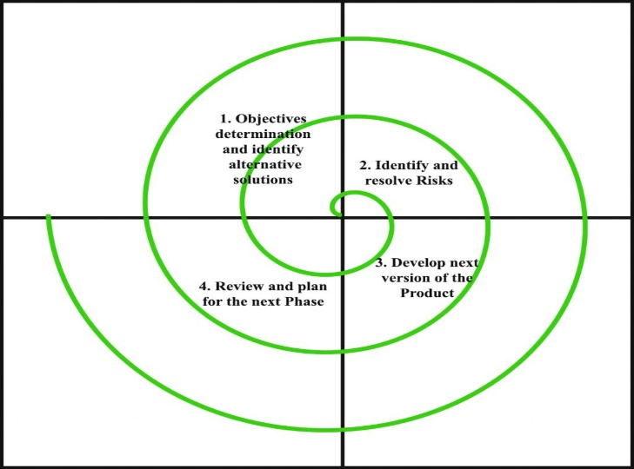

It is the combination of waterfall and iterative model. Each phase in spiral model begins with design goal and ends with client feedbacks. In this model I have manly alienated in five main parts they are:

* Communication
* Planning ( Estimating, Scheduling, Risk Analysis)
* Modeling ( Analysis of Design )
* Construction ( Code Test )
* Deployment ( Delivery, Support, Feedback)

The spiral round which moves around the five elements is called task reasons. The task reasons are:

* Concept Development
* System Development
* System Enhancement
* System Maintenance

# 7. Features

When the first user opens the application they have the option of sign up with Facebook or Gmail or give there details. After sign up they can login. The landing page after login is feeds where they will find all the updates, posts of different Companies. In feeds the companies can post what’s on their mind, in feeds enterprises can also post the deals and they can do marketing on the feeds. The enterprises can go to their profile and update or edit there information. The enterprises can also share their URL to others.

When any others users click on freelancer there they will have various choice which one to choose. For example if the person will choose marketing then all the Company with their ratings and deals will show up if you like the Company you can click on that company and it will take you to that company page where you will find all the details of the company, there works and their comments given by the other customer and their ratings. Some more features will be added when the project will continue.

# 8. Design or a Basic Layout of website

The basic design thought of at the initial phase is given below

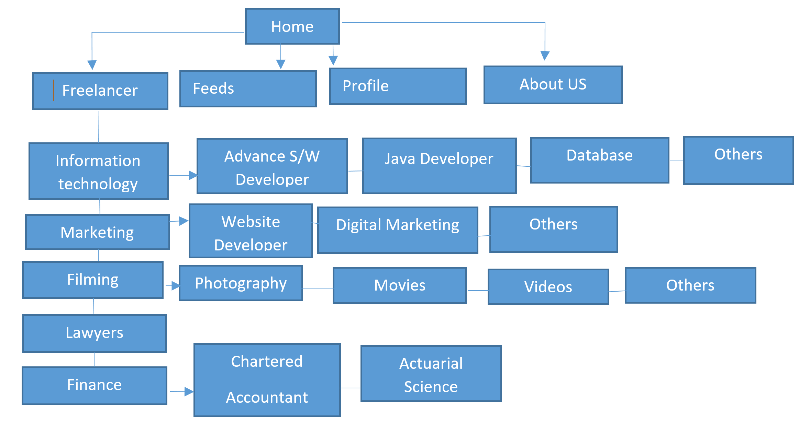

Figure 1 : Basic Layout of website

9. Resource Requirements:

The resource requirement will be assessed as the project moves forward.

10. Work breakdown structure:

|  |  |  |
| --- | --- | --- |
|  |  |  |
| |  |  |  | | --- | --- | --- | | **Spiral Mode** | **Date** | **Date** | | **Concept Development** |  |  | | Communication | 30th Oct | 10 Nov | | planning | 10th Nov | 20 Nov | | Modeling | 20th Nov | 5 Dec | | Construction | 5th Dec | 15 Dec | | Deployment | 15th Dec | 30 Dec | |  |  |  | | **System Development** |  |  | | communication | 30th Dec | 10 Jan | | planning | 10th Jan | 20 Jan | | Modeling | 20th Jan | 30 Jan | | Construction | 30th Jan | 20 Feb | | Deployment | 20th Fab | 30 Feb | | **System Enhancement** |  |  | | communication | 30th Feb | 10 Mar | | planning | 10th Mar | 20 Mar | | Modeling | 20th Mar | 25 Mar | | Construction | 25th Mar | 30 Mar | | Deployment | 30th Mar | 5 Apr | | **System**  **Maintenance** |  |  | | communication | 5th Apr | 10 Apr | | planning | 10th Apr | 15 Apr | | Modeling | 15th Apr | 20 Apr | | Construction | 20th Apr | 25 Apr | | Deployment | 25th Apr | 30 Apr | |
|  |
|  |
|  |
|  |
|  |

11. Milestones:

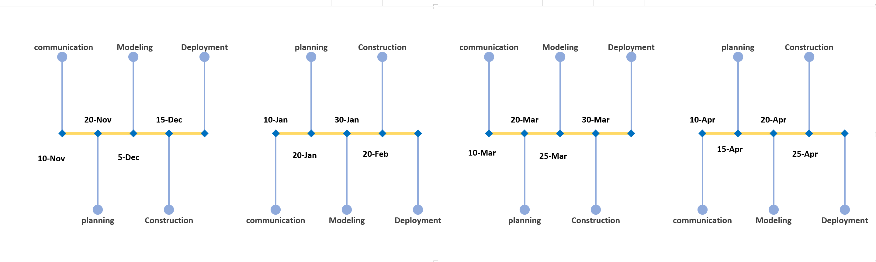

Figure 2: Milestones

# 12. Project Gantt chart with correct activity sequencing, duration and milestones

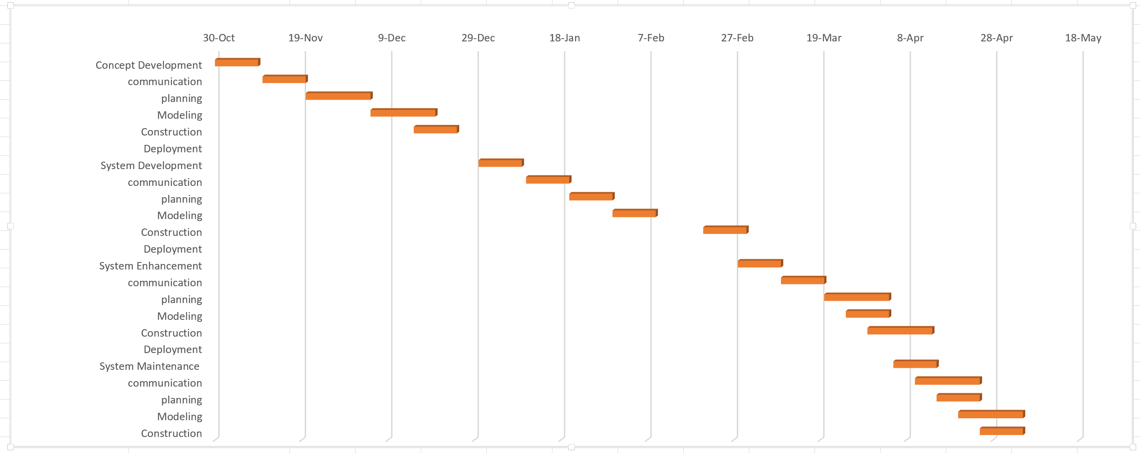

Figure 3 : Gantt chart.

According to the plan the project has been stared on 30 October which is Concept Development Inside concept development there are manly five elements which is Communication, Planning, Modeling, Construction and Deployment. Accordingly System Development, System Enhancement and System Maintenance have five elements. In the above figures all the dates with detail information have been provided.

# 13. Conclusion of the given proposal.

The project aims at developing a web development for various professionals and providing a one stop, user friendly application. The attempt at the outset looks very attractive but might tend to be a huge project requiring other expertise and resources. The detail breakdown of the project as foreseen is enumerated above but however would call for changes as required as the project moves forward, like a change in methodology and the likes. The project is inspired on seeing the gap between the requirement of freelancing services in one hand and its availability on the other hand. Small references will be taken from several online websites as required.

# 14. Clients

IT @ Himalaya <http://www.procit.com/en-us/wiewezijn.aspx>

Cyber Theque <https://cybertheque.net/>

Code Studio Solution <http://codestudiosolution.com.np/>

# 15. References

Anon., n.d. *BCcampus.* [Online]   
Available at: https://opentextbc.ca/projectmanagement/chapter/chapter-16-risk-management-planning-project-management/  
[Accessed 17 10 2019].

guru99, n.d. *guru99.* [Online]   
Available at: https://www.guru99.com/what-is-spiral-model-when-to-use-advantages-disadvantages.html  
[Accessed 17 10 2019].